**ASSIGNMENT 4**

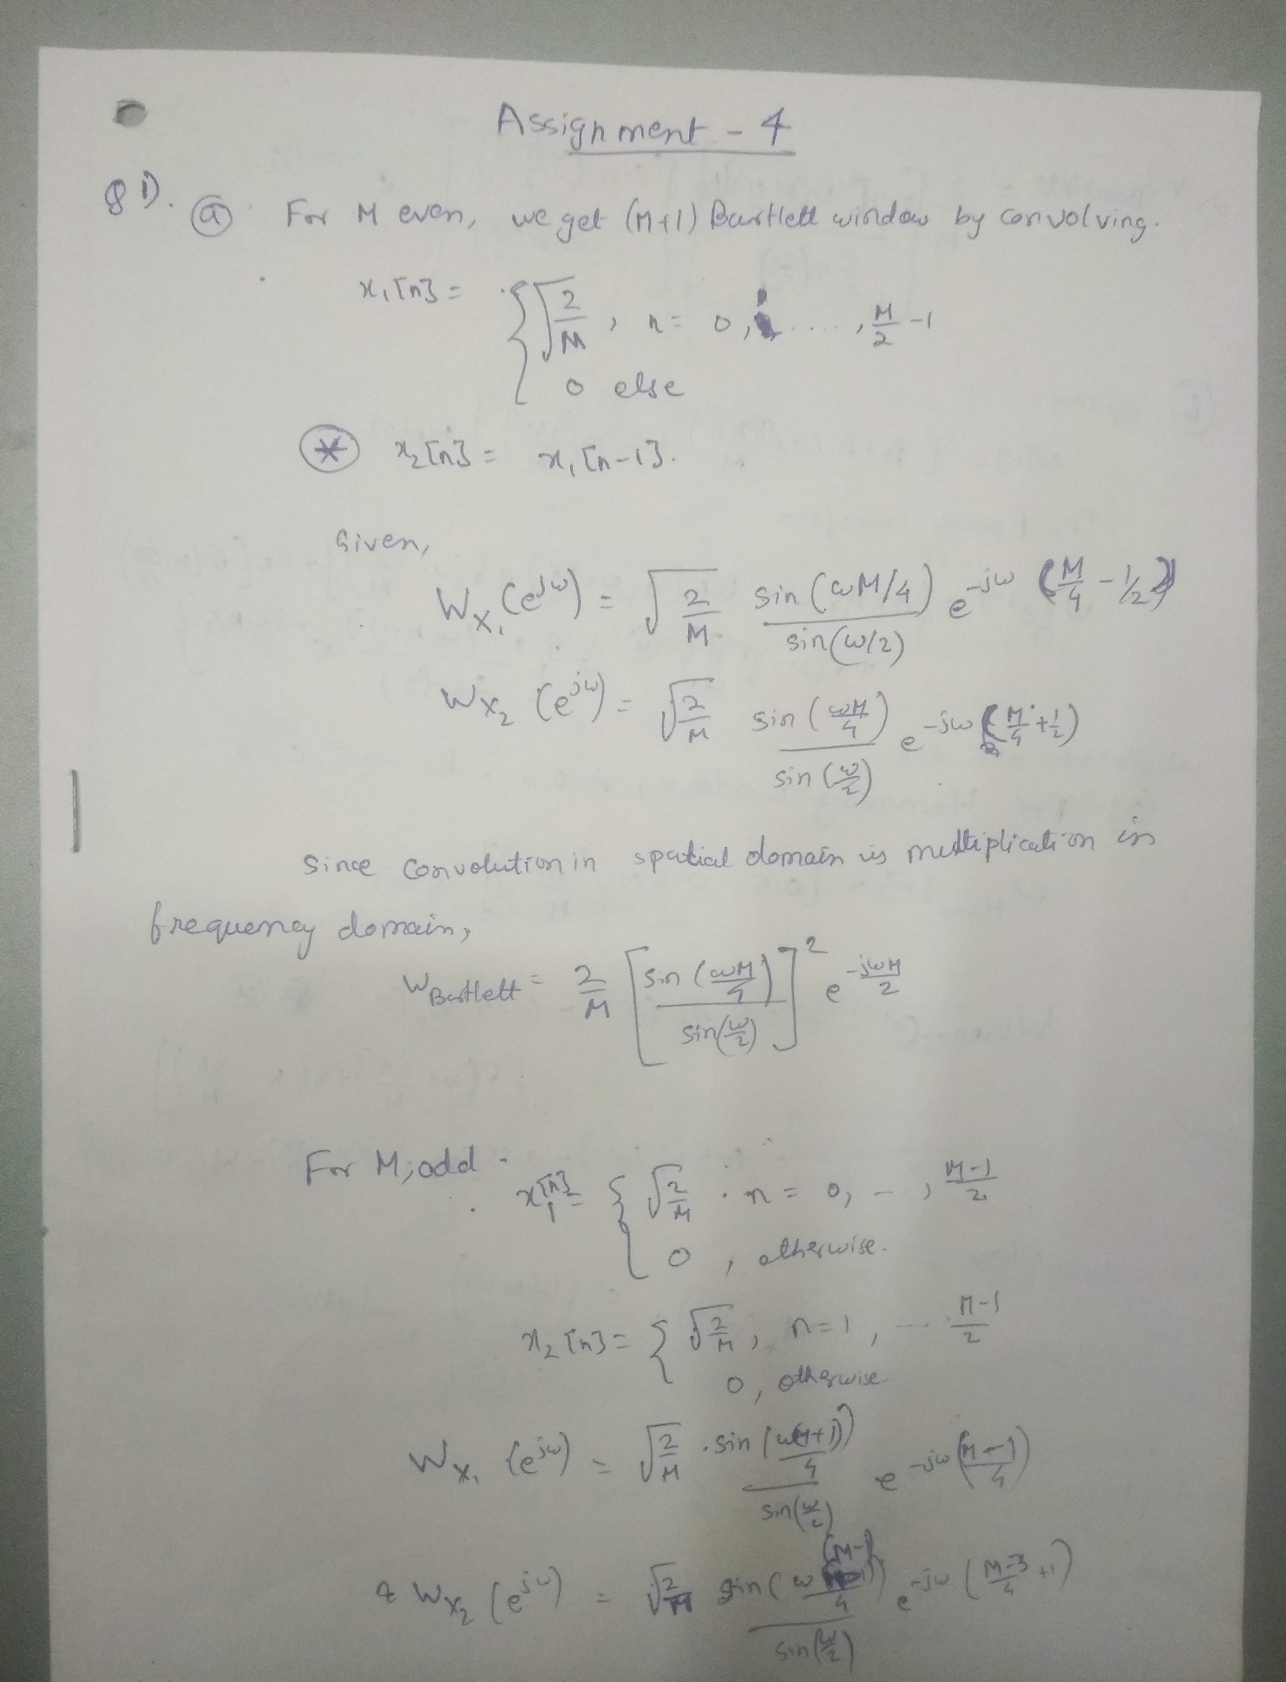

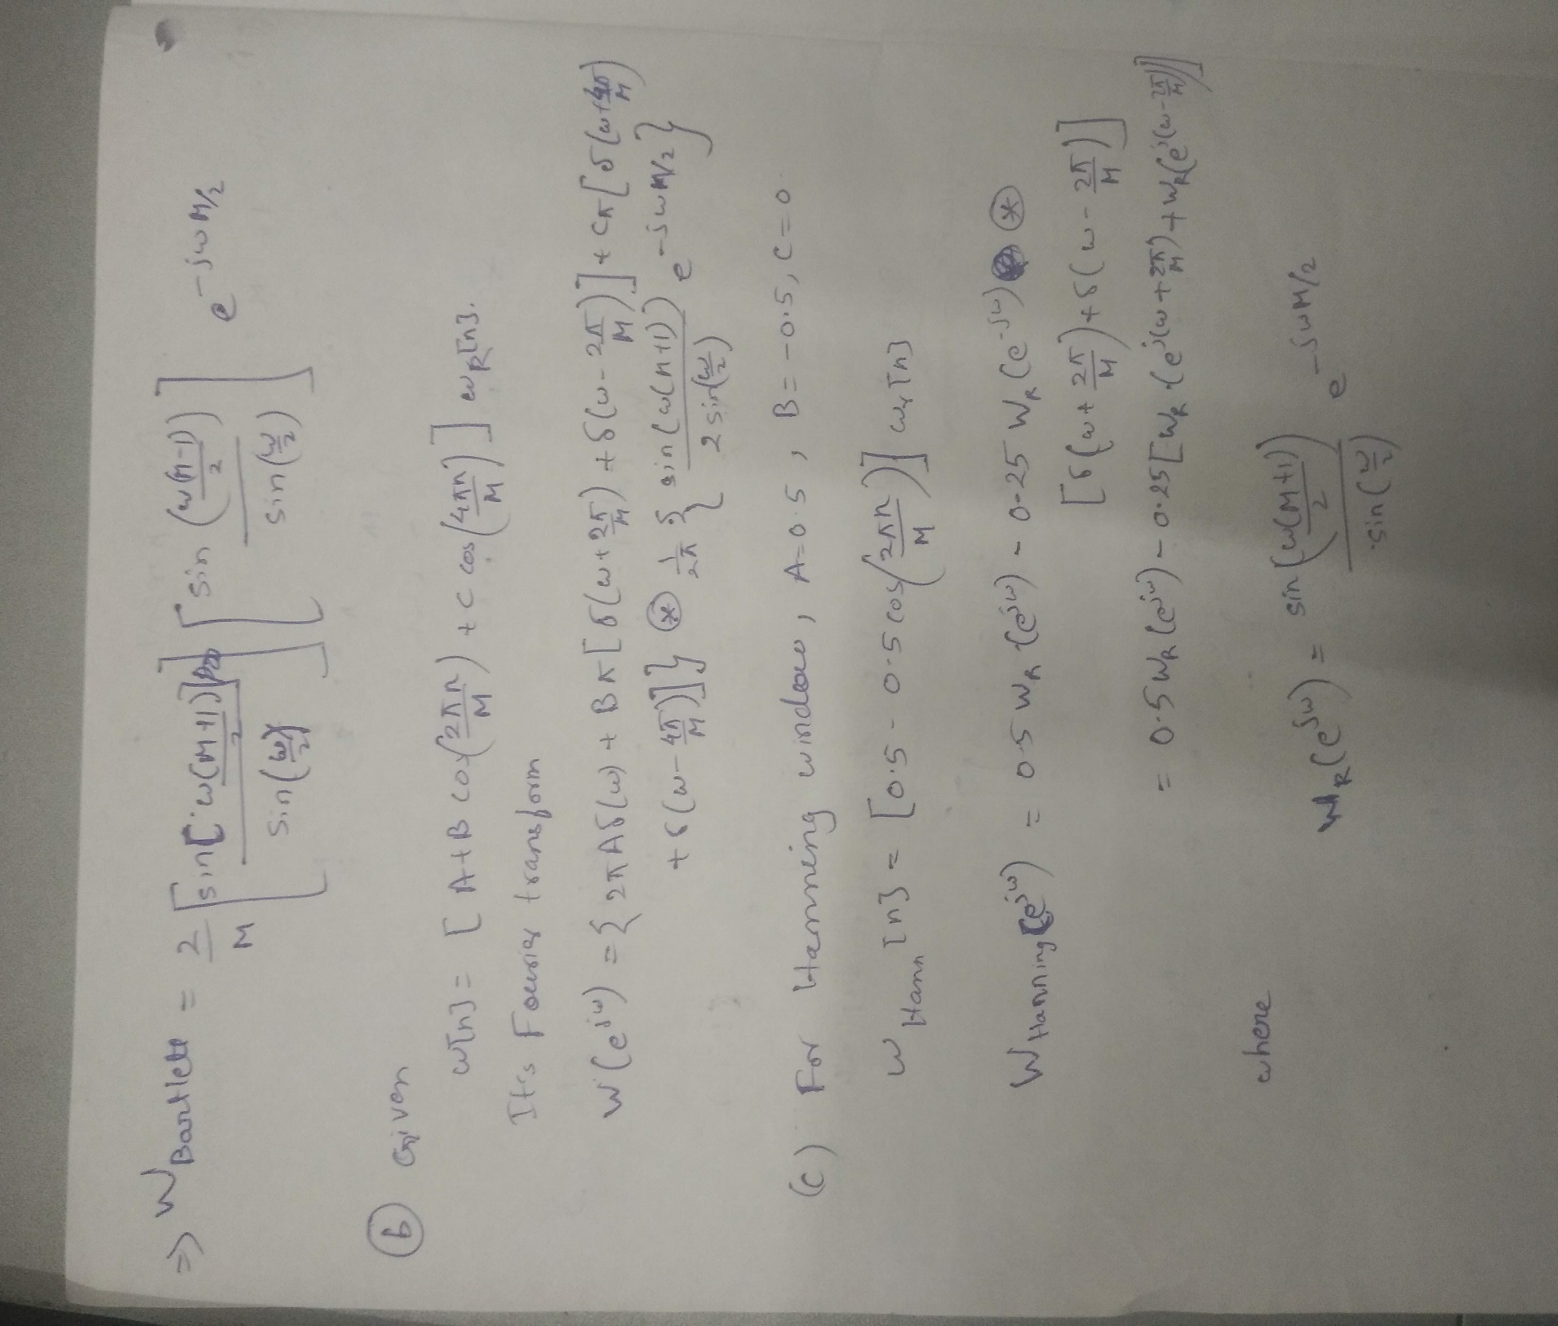

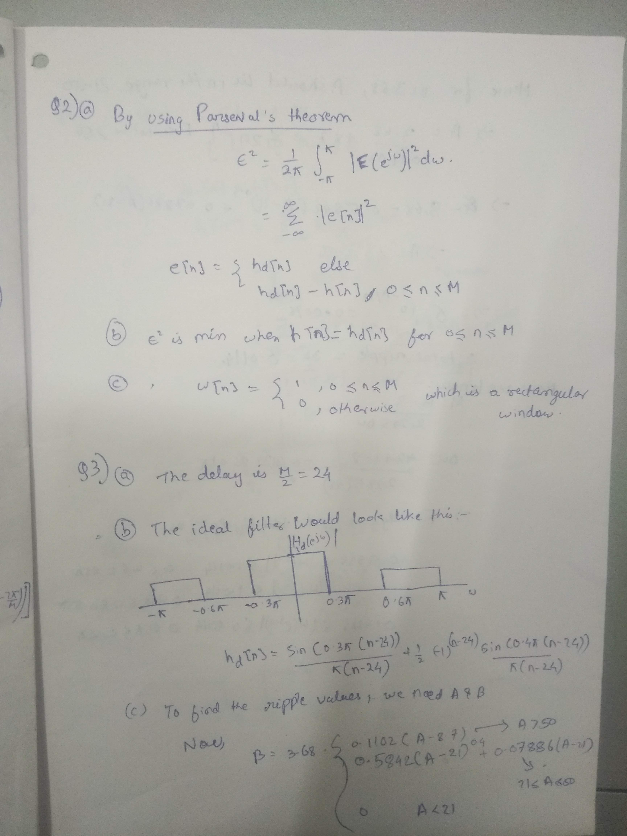

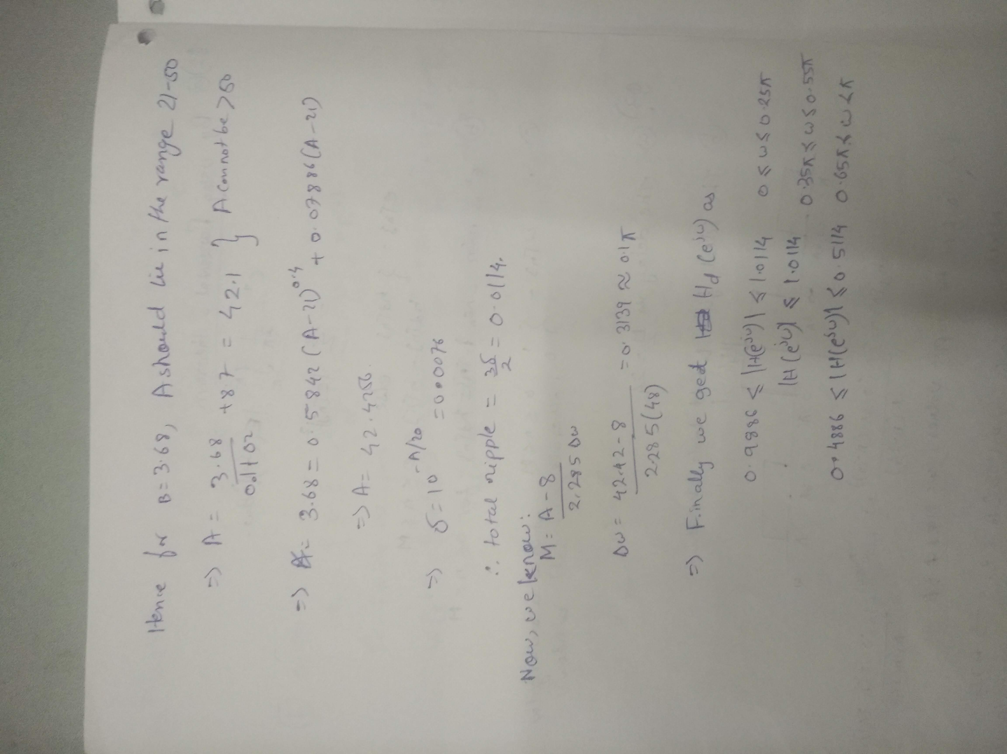

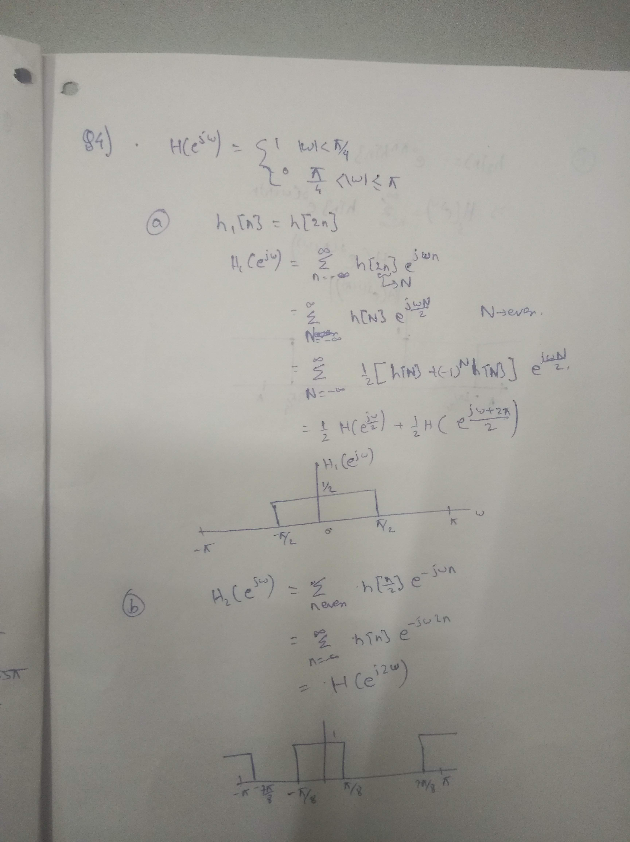

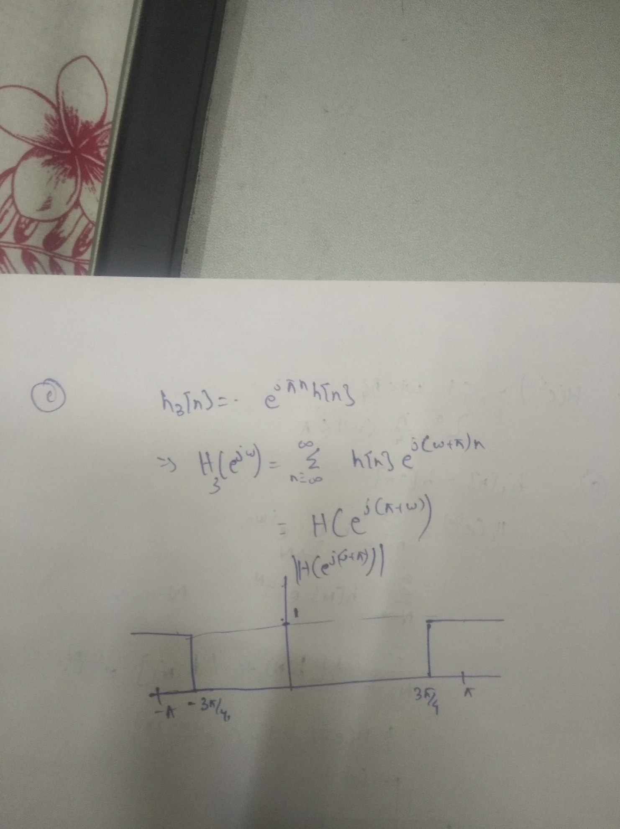

**Question 5(a)**

Code used:

pkg load signal;

clc;clear;

Wp = 0.65;

Ws = 0.7;

d1 = 1 - 10^(-1/20);

d2 = 10^(-75/20);

D1Db = 1;

D2Db = 75;

[Kaiser] = kaiserord([Wp, Ws], [1, 0], [d1, d2]);

[Remez] = remezord([Wp, Ws], [1, 0], [d1, d2]);

[Ellip] = ellipord(Wp,Ws,D1Db,D2Db);

disp('Order of Kaiser Filter:');

disp(Kaiser);

disp('Order of filter using Parks-McClellan algorithm:');

disp(Remez);

disp('Order of filter using elliptical prototype filter:');

disp(Ellip);

Result:

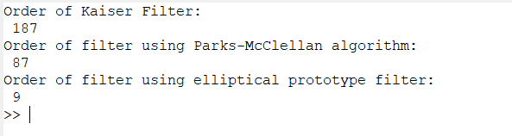

**(b)**Code:

pkg load signal;

clc;clear;

Wp = 0.65;

Ws = 0.7;

d1 = 1 - 10^(-1/20);

d2 = 10^(-75/20);

D1Db = 1;

D2Db = 75;

[Kaiser, Wn] = kaiserord([Wp, Ws], [1, 0], [d1, d2]);

[Remez,Fo,Ao,W] = remezord([Wp, Ws], [1, 0], [d1, d2]);

[Ellip1, Ellip2] = ellipord(Wp,Ws,D1Db,D2Db);

[Be, Ae] = ellip (Ellip1,D1Db,D2Db,Ellip2);

Bk = fir1 (Kaiser, Wn);

Br = remez(Remez,Fo,Ao,W);

freqz(Be, Ae);

freqz(Bk);

freqz(Br);

Plot of Kaiser filter:

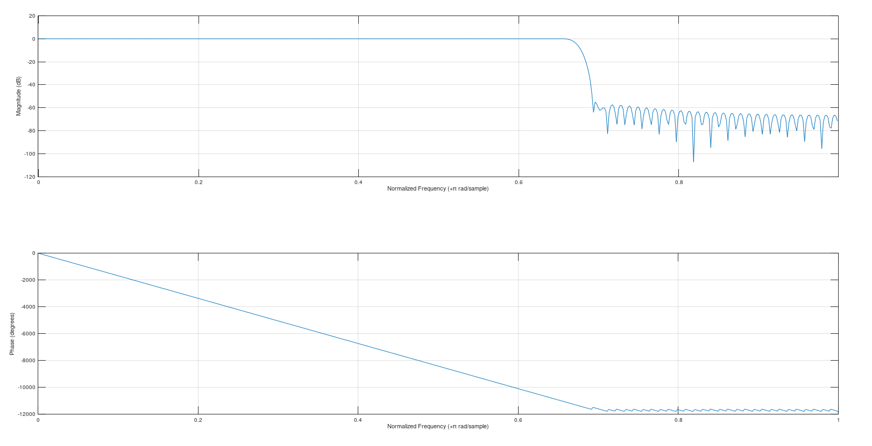

Plot of remez filter

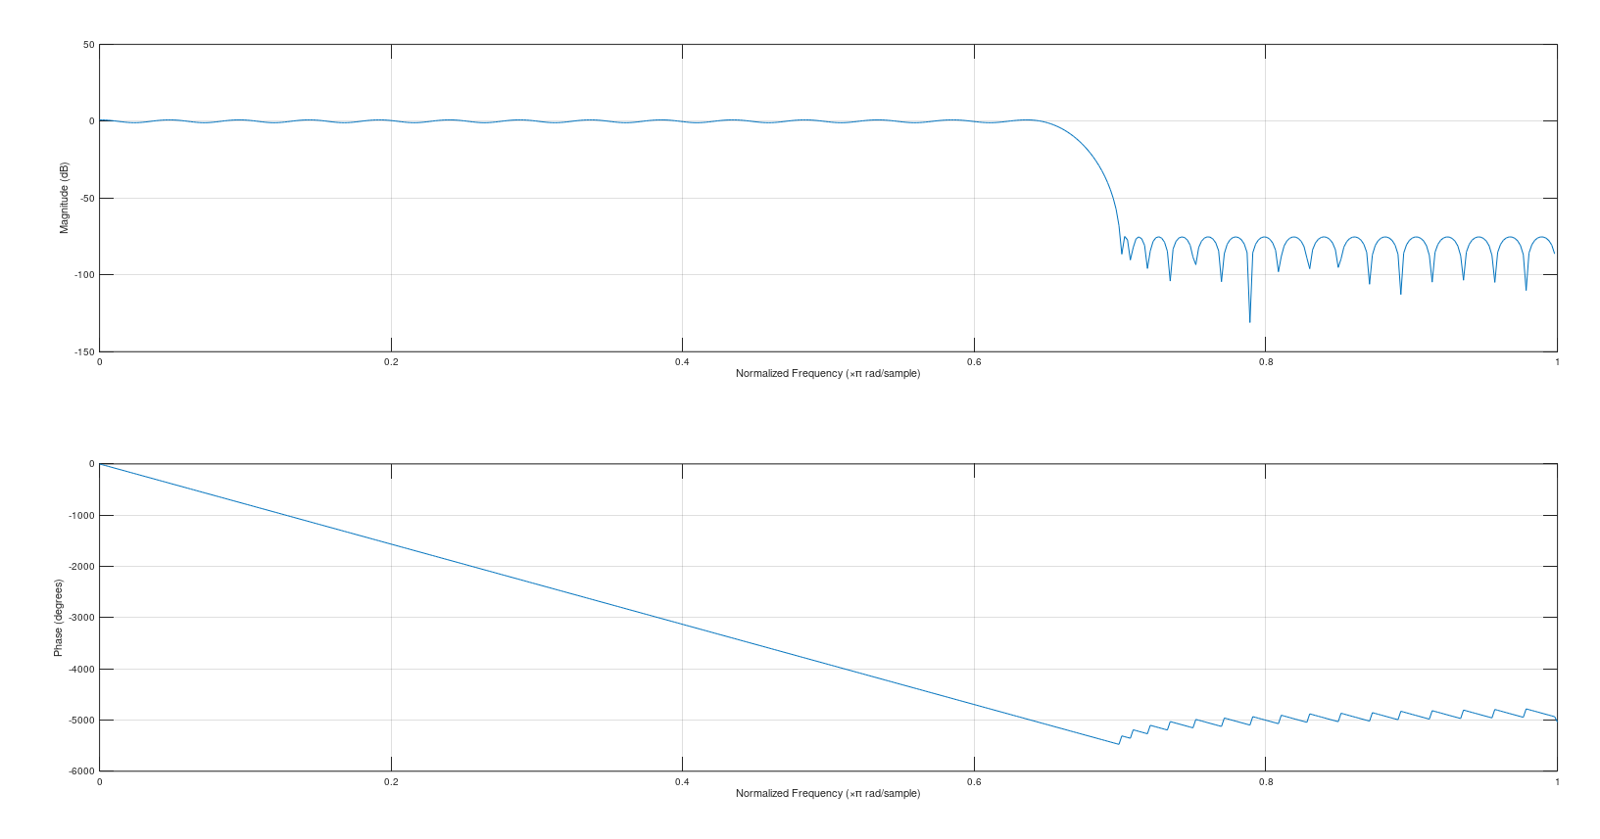

Plot of elliptical filter:

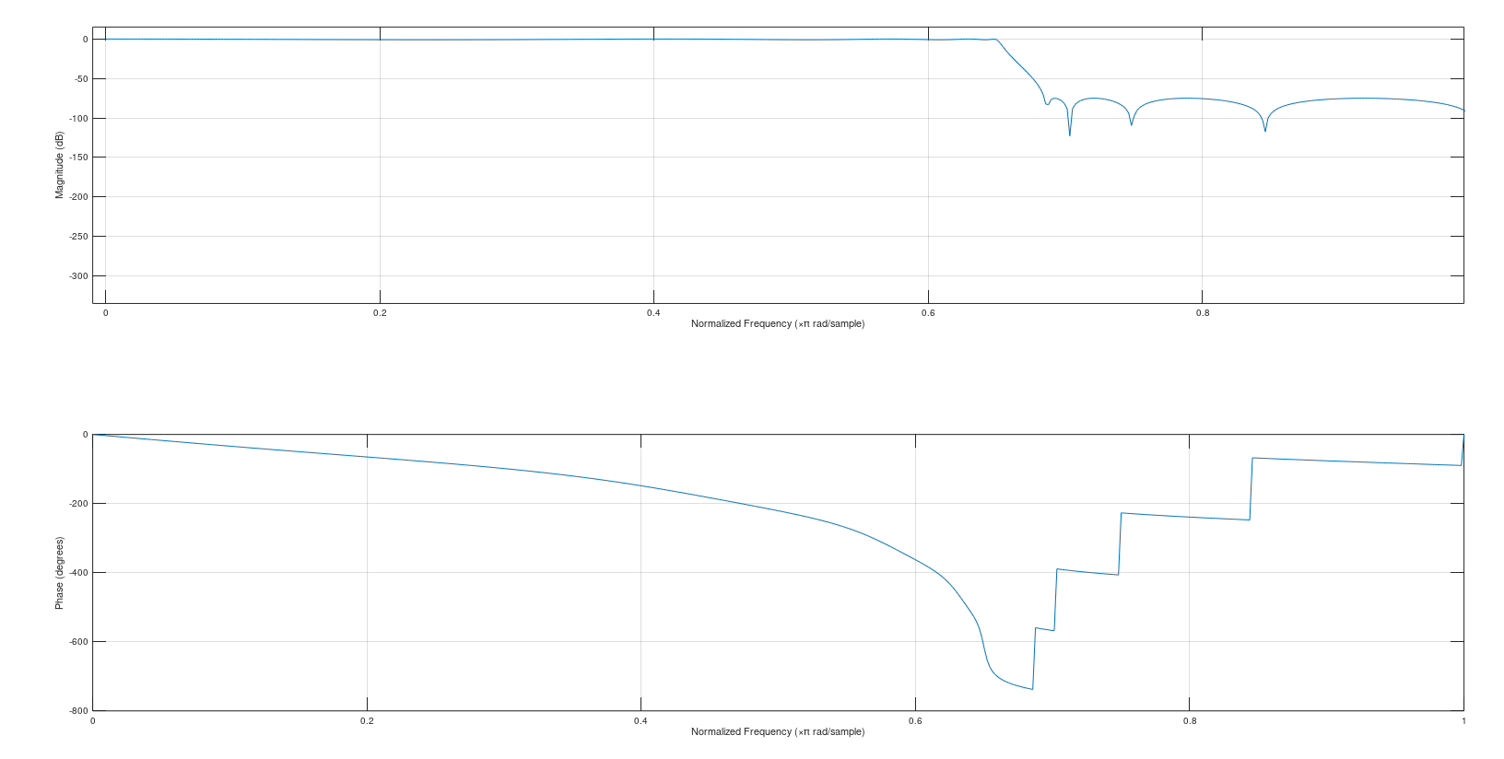

**Coefficients:**

1. **Kaiser filter numerator coefficients (denominator is 1):**

Columns 1 through 6:

-0.00001805950 0.00023891018 -0.00023500876 0.00000038154 0.00024934614 -0.00027002007

Columns 7 through 12:

0.00002246885 0.00027181585 -0.00032287147 0.00005200365 0.00030512085 -0.00039621388

Columns 13 through 18:

0.00009317188 0.00034741304 -0.00049239292 0.00015049588 0.00039617154 -0.00061337811

Columns 19 through 24:

0.00022878371 0.00044818704 -0.00076069877 0.00033307893 0.00049955226 -0.00093538823

Columns 25 through 30:

0.00046861476 0.00054565616 -0.00113793795 0.00064077684 0.00058117839 -0.00136826273

Columns 31 through 36:

0.00085508032 0.00060007941 -0.00162567822 0.00111716803 0.00059557941 -0.00190889137

Columns 37 through 42:

0.00143283879 0.00056011694 -0.00221600438 0.00180811773 0.00048527429 -0.00254453233

Columns 43 through 48:

0.00224938511 0.00036165102 -0.00289143430 0.00276358712 0.00017865867 -0.00325315746

Columns 49 through 54:

0.00335856360 -0.00007580413 -0.00362569351 0.00404354607 -0.00041585937 -0.00400464618

Columns 55 through 60:

0.00482991106 -0.00085844119 -0.00438530855 0.00573232857 -0.00142453945 -0.00476274851

Columns 61 through 66:

0.00677054495 -0.00214118579 -0.00513190069 0.00797222724 -0.00304470753 -0.00548766266

Columns 67 through 72:

0.00937766822 -0.00418624820 -0.00582499342 0.01104793442 -0.00564157225 -0.00613901207

Columns 73 through 78:

0.01307980626 -0.00752953114 -0.00642509431 0.01563520476 -0.01004956943 -0.00667896473

Columns 79 through 84:

0.01900471556 -0.01356582594 -0.00689678275 0.02376247597 -0.01882289064 -0.00707522026

Columns 85 through 90:

0.03121436628 -0.02761844710 -0.00721152932 0.04508708295 -0.04567721715 -0.00730359814

Columns 91 through 96:

0.08190336103 -0.10621702674 -0.00734999436 0.55486154469 0.55486154469 -0.00734999436

Columns 97 through 102:

-0.10621702674 0.08190336103 -0.00730359814 -0.04567721715 0.04508708295 -0.00721152932

Columns 103 through 108:

-0.02761844710 0.03121436628 -0.00707522026 -0.01882289064 0.02376247597 -0.00689678275

Columns 109 through 114:

-0.01356582594 0.01900471556 -0.00667896473 -0.01004956943 0.01563520476 -0.00642509431

Columns 115 through 120:

-0.00752953114 0.01307980626 -0.00613901207 -0.00564157225 0.01104793442 -0.00582499342

Columns 121 through 126:

-0.00418624820 0.00937766822 -0.00548766266 -0.00304470753 0.00797222724 -0.00513190069

Columns 127 through 132:

-0.00214118579 0.00677054495 -0.00476274851 -0.00142453945 0.00573232857 -0.00438530855

Columns 133 through 138:

-0.00085844119 0.00482991106 -0.00400464618 -0.00041585937 0.00404354607 -0.00362569351

Columns 139 through 144:

-0.00007580413 0.00335856360 -0.00325315746 0.00017865867 0.00276358712 -0.00289143430

Columns 145 through 150:

0.00036165102 0.00224938511 -0.00254453233 0.00048527429 0.00180811773 -0.00221600438

Columns 151 through 156:

0.00056011694 0.00143283879 -0.00190889137 0.00059557941 0.00111716803 -0.00162567822

Columns 157 through 162:

0.00060007941 0.00085508032 -0.00136826273 0.00058117839 0.00064077684 -0.00113793795

Columns 163 through 168:

0.00054565616 0.00046861476 -0.00093538823 0.00049955226 0.00033307893 -0.00076069877

Columns 169 through 174:

0.00044818704 0.00022878371 -0.00061337811 0.00039617154 0.00015049588 -0.00049239292

Columns 175 through 180:

0.00034741304 0.00009317188 -0.00039621388 0.00030512085 0.00005200365 -0.00032287147

Columns 181 through 186:

0.00027181585 0.00002246885 -0.00027002007 0.00024934614 0.00000038154 -0.00023500876

Columns 187 and 188:

0.00023891018 -0.00001805950

1. **Remez filter numerator coefficients (denominator is 1):**

|  |  |  |
| --- | --- | --- |
| 0.0011668  0.0118295  0.0287624  0.0222282  -0.0075886  -0.0113213  0.0091344  0.0032884  -0.0092531  0.0041424  0.0047157  -0.0079844  0.0027465  0.0052880  -0.0080089  0.0023667  0.0061102  -0.0087803  0.0023083  0.0073127  -0.0101422  0.0023379  0.0090053  -0.0120384  0.0023808  0.0112758  -0.0146316  0.0024482  0.0144501  -0.0182602 | 0.0024688  0.0190730  -0.0235856  0.0024839  0.0263922  -0.0324510  0.0025260  0.0401906  -0.0505878  0.0025390  0.0769838  -0.1111697  0.0025366  0.5499894  0.5499894  0.0025366  -0.1111697  0.0769838  0.0025390  -0.0505878  0.0401906  0.0025260  -0.0324510  0.0263922  0.0024839  -0.0235856  0.0190730  0.0024688  -0.0182602  0.0144501  0.0024482 | -0.0146316  0.0112758  0.0023808  -0.0120384  0.0090053  0.0023379  -0.0101422  0.0073127  0.0023083  -0.0087803  0.0061102  0.0023667  -0.0080089  0.0052880  0.0027465  -0.0079844  0.0047157  0.0041424  -0.0092531  0.0032884  0.0091344  -0.0113213  -0.0075886  0.0222282  0.0287624  0.0118295  0.0011668 |

**3) Elliptical filter numerator coefficients:**

Columns 1 through 9:

0.044242 0.286369 0.910214 1.832455 2.557091 2.557091 1.832455 0.910214 0.286369

Column 10:

0.044242

**4) Elliptical filter denominator coefficients:**

Columns 1 through 9:

1.000000 1.396246 3.175523 2.103584 2.682755 0.522894 0.795235 -0.321702 0.059753

Column 10:

-0.153546

**Question 6**

**a)**

**Code:**

pkg load signal;

clc;clear;

[audio,Fs] = audioread('audio_cut.wav');

rip = 200;

w4_l = 2*(4000 - rip/2)/Fs;

w4_h = 2*(4000 + rip/2)/Fs;

w4 = 2*4000/Fs;

w8_l = 2*(8000 - rip/2)/Fs;

w8_h = 2*(8000 + rip/2)/Fs;

w8 = 2*8000/Fs;

w12_l = 2*(12000 - rip/2)/Fs;

w12_h = 2*(12000 + rip/2)/Fs;

w12 = 2*12000/Fs;

w16_l = 2*(16000 - rip/2)/Fs;

w16_h = 2*(16000 + rip/2)/Fs;

w16 = 2*16000/Fs;

[b1,a1] = butter(6,w4);

[b2,a2] = butter(6,[w4,w8]);

[b3,a3] = butter(6,[w8,w12]);

[b4,a4] = butter(6,[w12,w16]);

rfil(1,:) = remez(200, [0, w4_l, w4_h, 1], [1,1,0,0]);

rfil(2,:) = remez(200, [0, w4_l, w4_h, w8_l, w8_h, 1], [0, 0, 1, 1, 0, 0]);

rfil(3,:) = remez(200, [0, w8_l, w8_h, w12_l, w12_h, 1], [0, 0, 1, 1, 0, 0]);

rfil(4,:) = remez(200, [0, w12_l, w12_h, w16_l, w16_h, 1], [0, 0, 1, 1, 0, 0]);

y1(:,1) = conv(rfil(1,:)',audio(:,1));

y1(:,2) = conv(rfil(1,:)',audio(:,2));

y2(:,1) = conv(rfil(2,:)',audio(:,1));

y2(:,2) = conv(rfil(2,:)',audio(:,2));

y3(:,1) = conv(rfil(3,:)',audio(:,1));

y3(:,2) = conv(rfil(3,:)',audio(:,2));

y4(:,1) = conv(rfil(4,:)',audio(:,1));

y4(:,2) = conv(rfil(4,:)',audio(:,2));

ybut1(:,1) = filter(b1,a1,audio(:,1));

ybut1(:,2) = filter(b1,a1,audio(:,2));

ybut2(:,1) = filter(b2,a2,audio(:,1));

ybut2(:,2) = filter(b2,a2,audio(:,2));

ybut3(:,1) = filter(b3,a3,audio(:,1));

ybut3(:,2) = filter(b3,a3,audio(:,2));

ybut4(:,1) = filter(b4,a4,audio(:,1));

ybut4(:,2) = filter(b4,a4,audio(:,2));

Obviously,

rfil is the remez filter array,  
audio is the audio file (trimmed to the first 20 seconds),   
[b,a] are the butterworth filters  
y1-y4 are the filtered audio files of the remez filter  
and ybut1-ybut3 are the filtered audio files of the butterworth filters.

1. **Freqz of the individual filters**

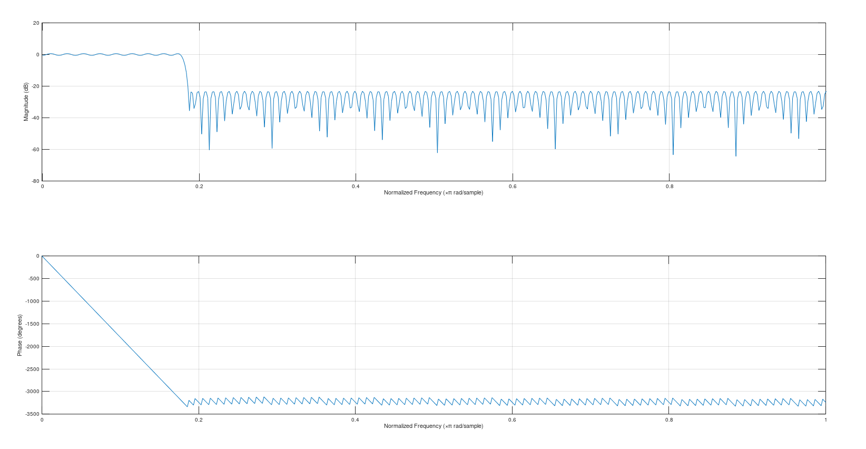

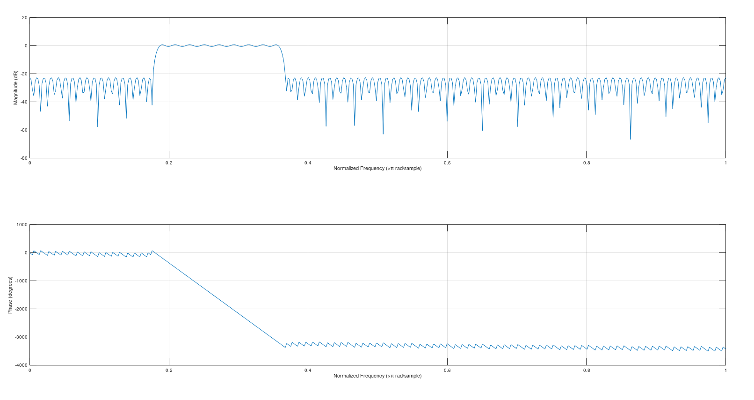

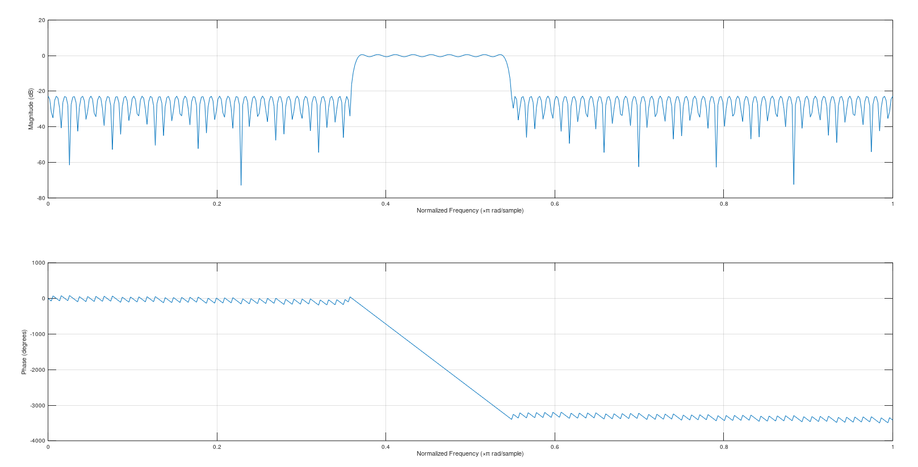

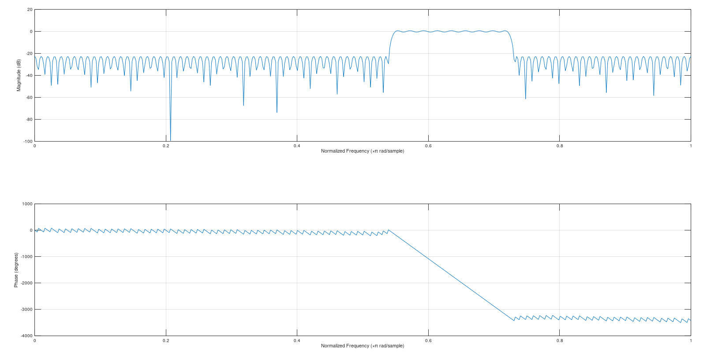

**b)**  
**RESULTS/INFERENCES:**

After filtering with 0-4kHz filter:  
 Violin sound has been focused on, rest dampened

After filtering with 4-8kHz filter:  
 Violin enhanced, but to a lesser extent

After filtering with 8-12kHz filter:  
 No particular sound amplified, but it seems the noise has greater  
 effect now.

After filtering with 12-16kHz filter:  
 Metallic components of all instruments enhanced (high frequencies)

**c)**

**Butterworth filters plots**

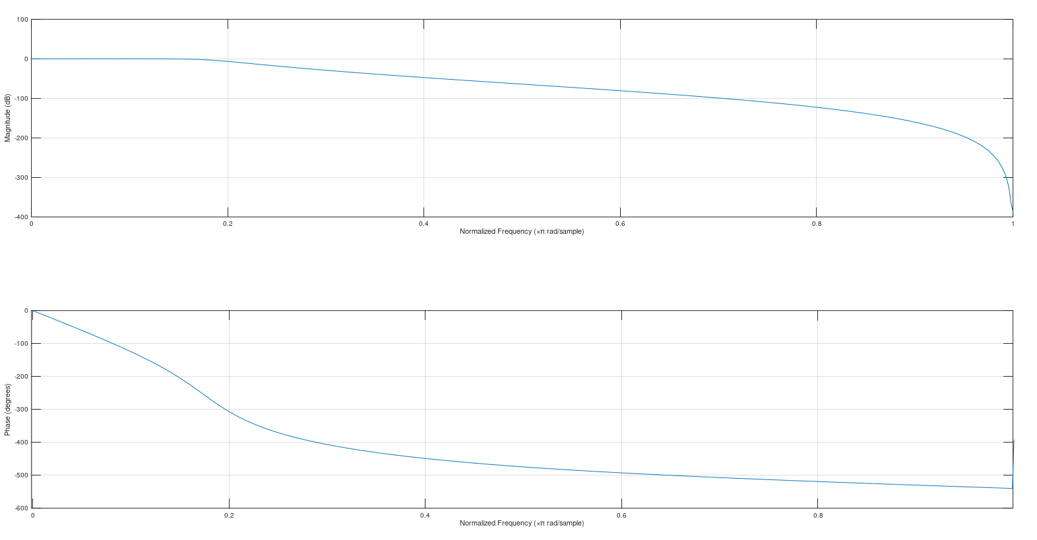

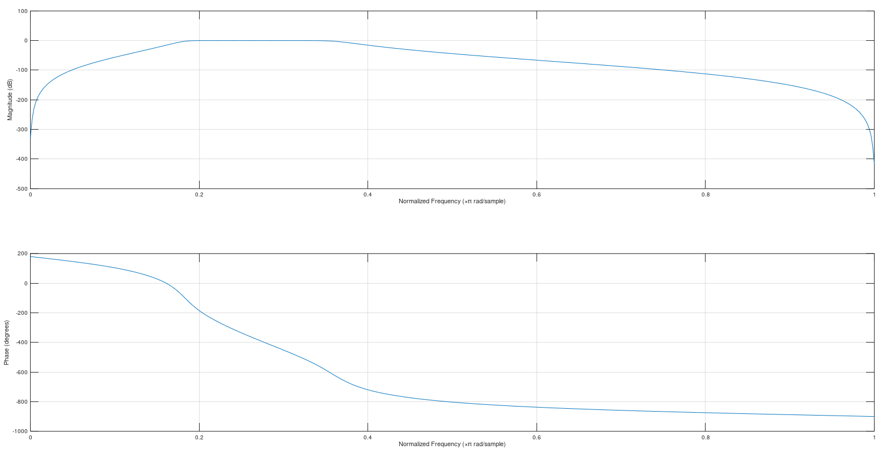

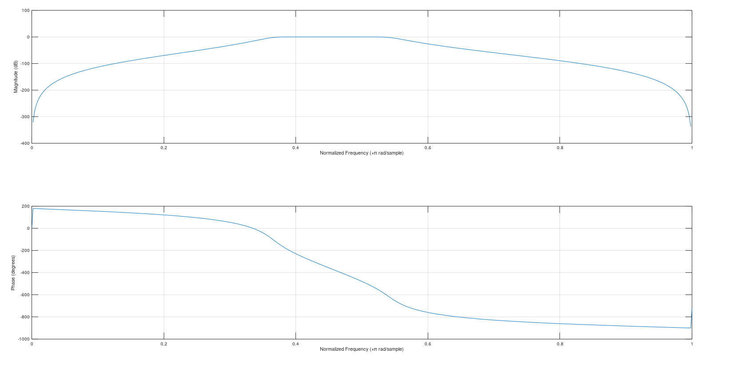

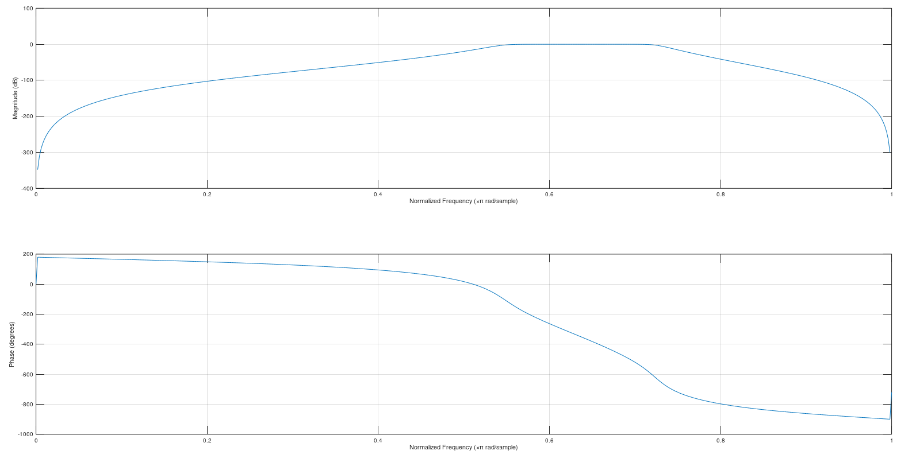

Inferences

Many distinct changes could be observed. The low pass filtered signal could be seen to have almost all the frequencies intact but the other filters seem to have filtered out all the instruments completely, and only left a few frequencies behind. Only the sounds like those made by crickets were left behind.

Freqz of original audio signal: (channel 1)

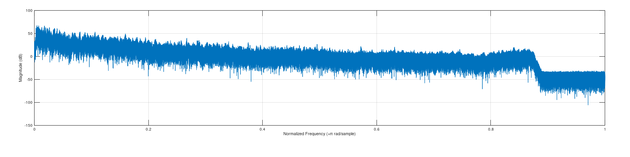

Channel 2:

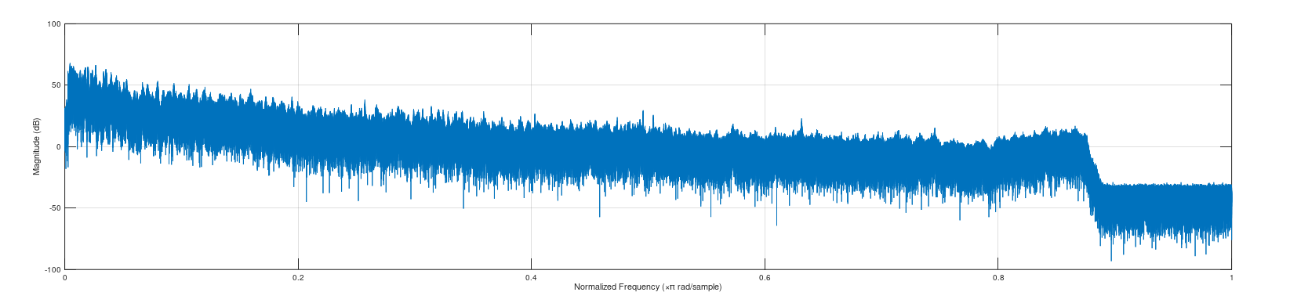

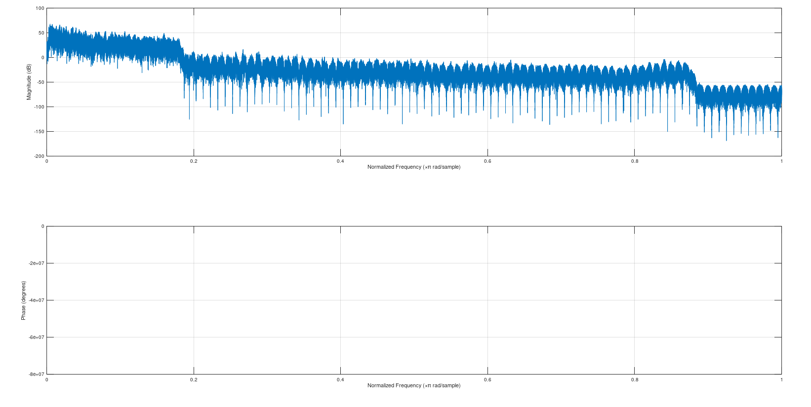Freqz of remez filtered audio signals (channel 1):

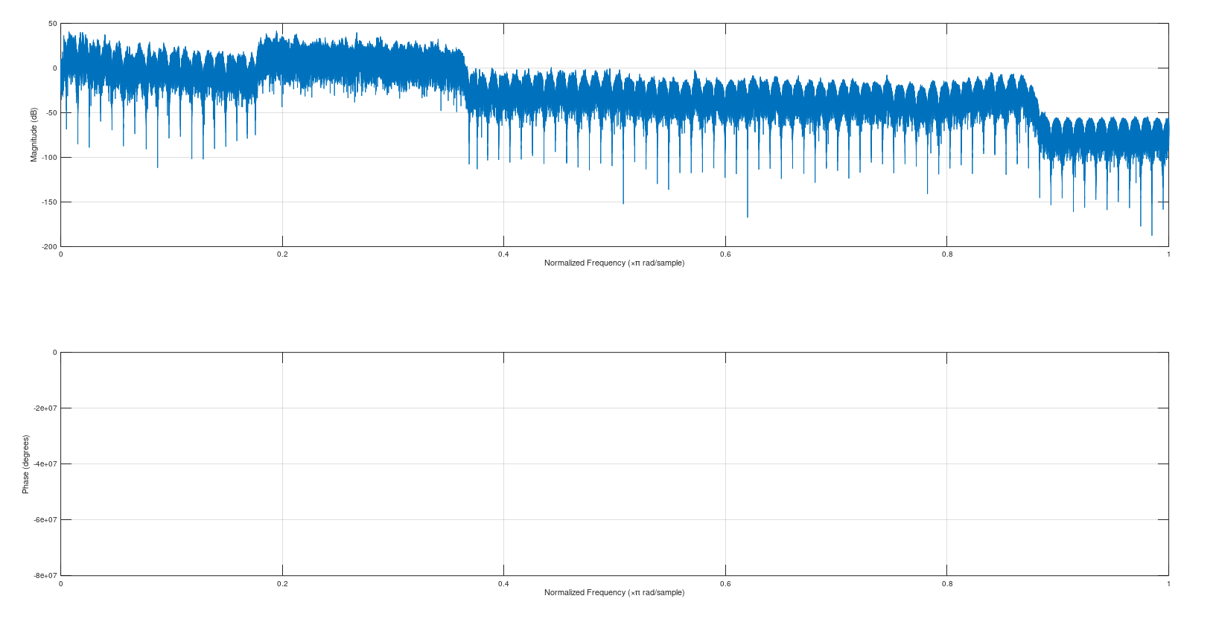

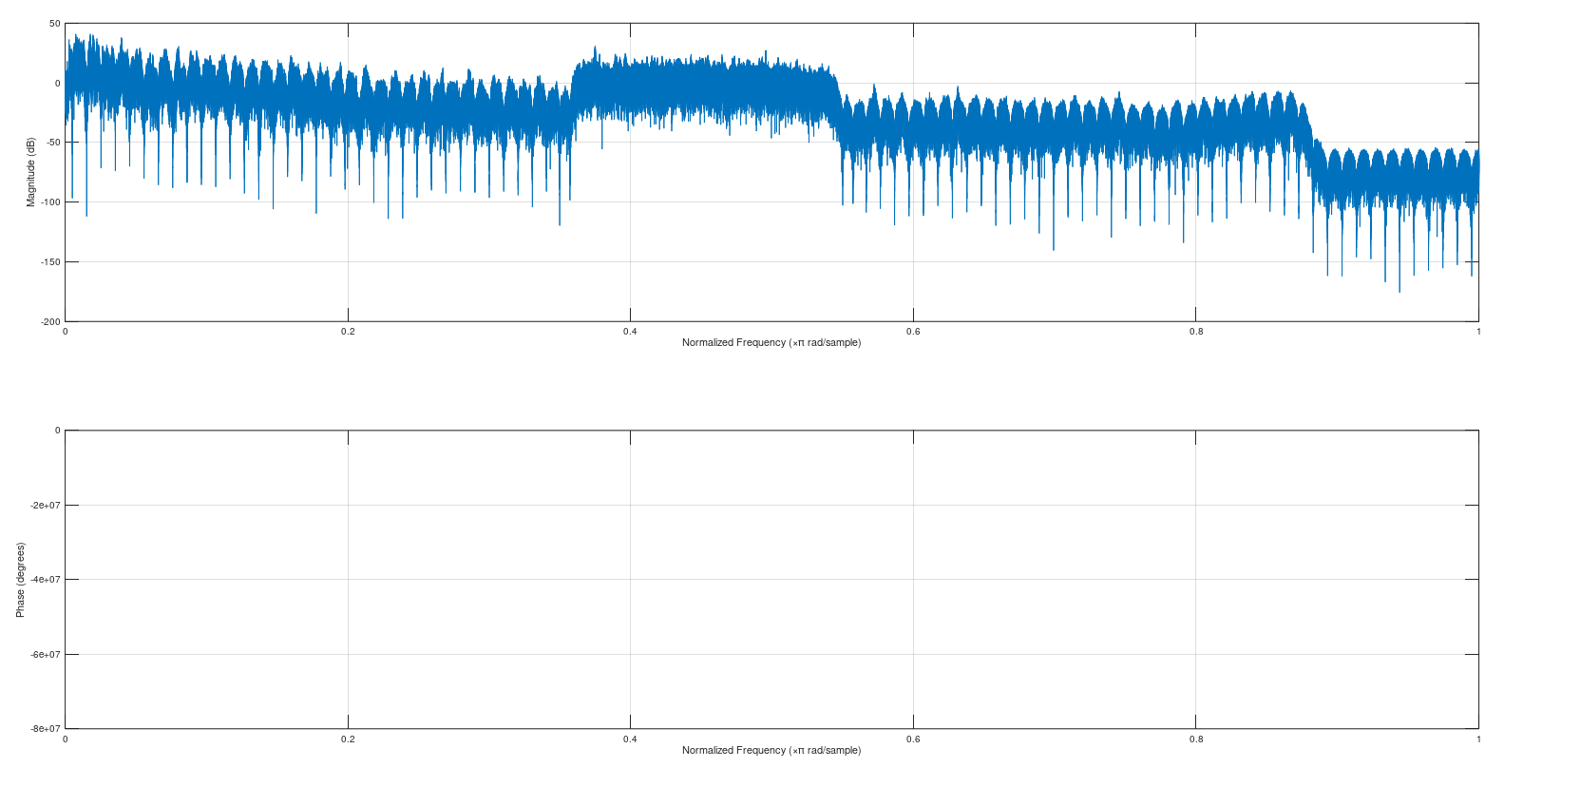

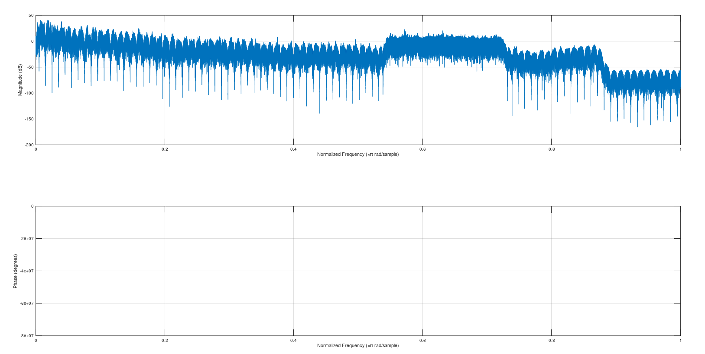

Freqz of Butterworth filtered audio signals (Channel 1):

